DK WHEEL INSTALLATION INSTRUCTIONS

Tools required:
1 x Snap Ring Pliers
1 x Hand Drill
1 x 19 mm Socket
2 x Front Wheels (Included in box)
2 x Snap Rings (Included in box)
2 x Rear Wheels (Included in box)
2 x Bolts (Included in box)
2 x Washers (Included in box)

Step 1. Open the box containing your jack, instructions and parts.

Step 2. Identify your parts bags. (Pictured below the Front Wheels and Snap rings are in the left bag and the Rear Wheels, Bolts and Washers)

Link to video instructions:


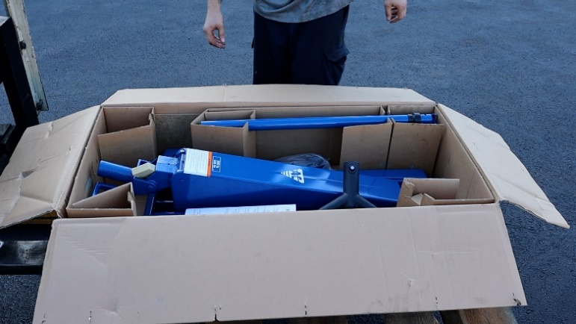

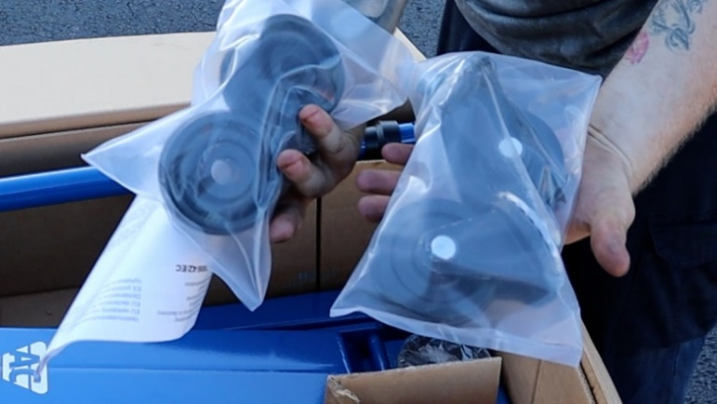

Step 3. Pull front end of jack out of the box and rest on the side of the box.

Step 4. Place front wheel on the jack.

Step 5. Use your snap ring pliers to install the snap ring.

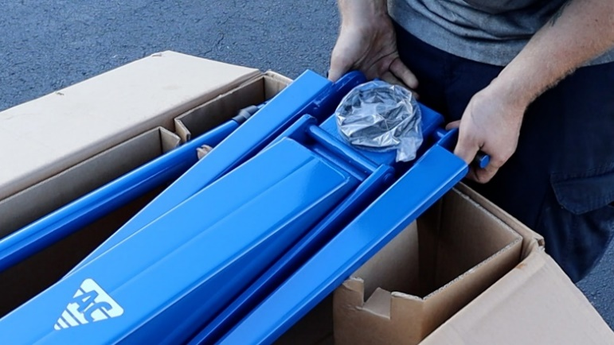

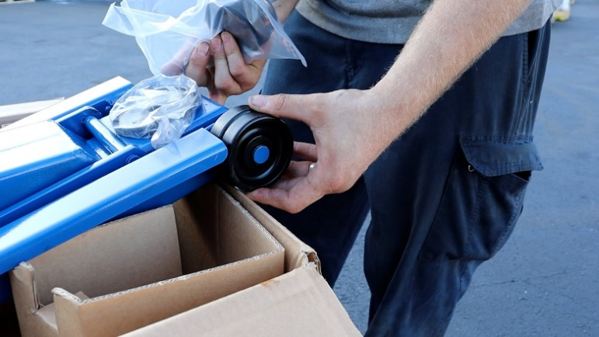

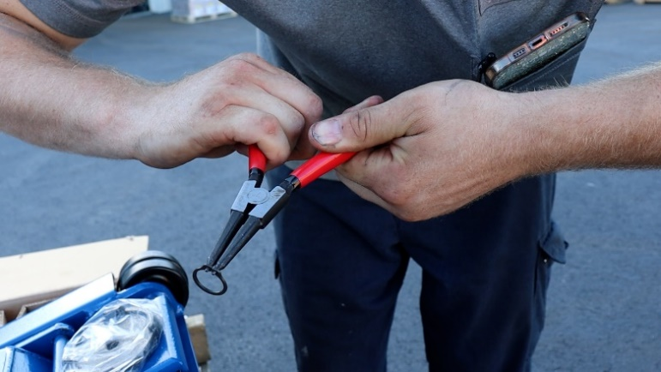

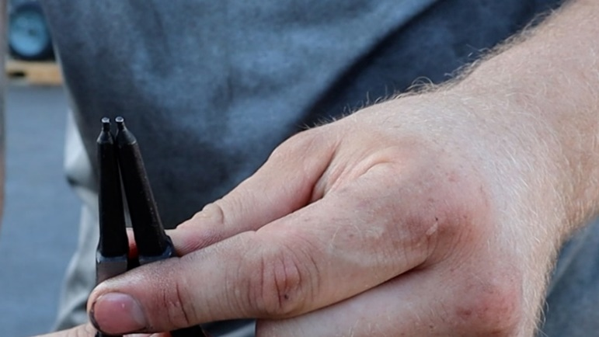

Step 6. Move jack back into box to start rear wheel installation.

Step 7. Pull rear end of jack out of the box and rest on the side of the box.

Step 8. Grab rear wheels, bolts and washers out of the bag. Make sure the exposed ball bearings are faced down when installing.

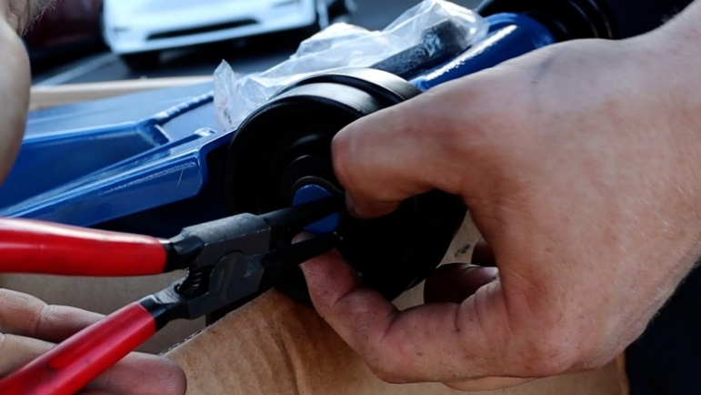

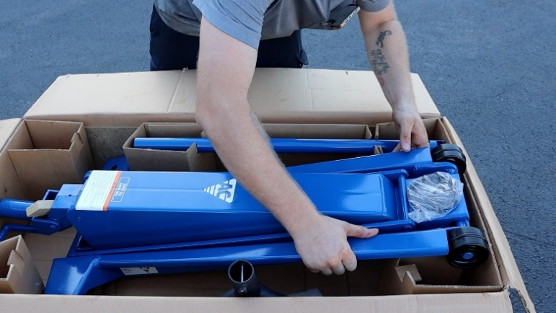

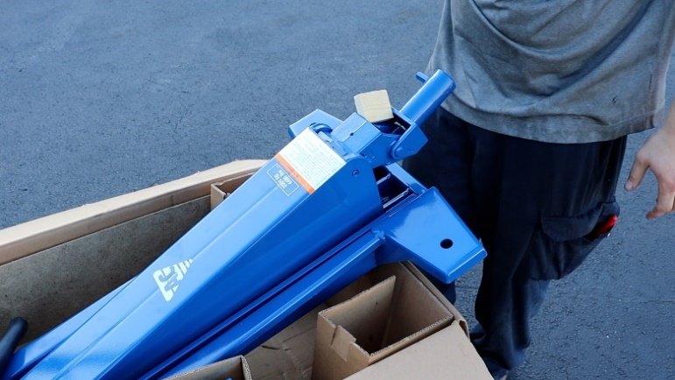

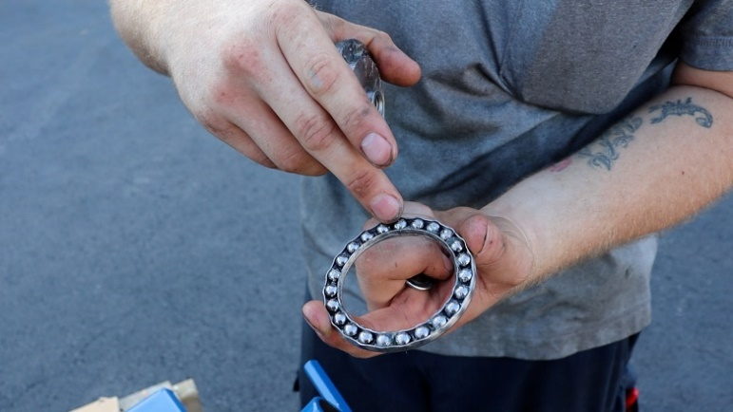

Step 9. Slide wheel into the hole and hand tighten the bolt/washer to the jack.

Step 10. Hold the wheel in place and using your hand drill and 19 mm socket, tighten the bolt to the jack.

